<https://docs.uniswap.org/concepts/governance/overview>

Overview

Code[​](https://docs.uniswap.org/concepts/governance/overview#code)

[governance](https://github.com/Uniswap/governance)

Documentation[​](https://docs.uniswap.org/concepts/governance/overview#documentation)

For reference material on the Uniswap Governance system please see [Governance Reference](https://docs.uniswap.org/contracts/v3/reference/governance/overview.md).

UNI Address[​](https://docs.uniswap.org/concepts/governance/overview#uni-address)

UNI is deployed at 0x1f9840a85d5aF5bf1D1762F925BDADdC4201F984 on the Ethereum [mainnet](https://etherscan.io/address/0x1f9840a85d5aF5bf1D1762F925BDADdC4201F984), and the [Ropsten](https://ropsten.etherscan.io/address/0x1f9840a85d5aF5bf1D1762F925BDADdC4201F984), [Rinkeby](https://rinkeby.etherscan.io/address/0x1f9840a85d5aF5bf1D1762F925BDADdC4201F984), [Görli](https://goerli.etherscan.io/address/0x1f9840a85d5aF5bf1D1762F925BDADdC4201F984), and [Kovan](https://kovan.etherscan.io/address/0x1f9840a85d5aF5bf1D1762F925BDADdC4201F984) testnets. It was built from commit [ab22c08](https://github.com/Uniswap/governance/commit/ab22c084bacb2636a1aebf9759890063eb6e4946).

ABI[​](https://docs.uniswap.org/concepts/governance/overview#abi)

*import* Uni *from* '@uniswap/governance/build/Uni.json'

Copy

<https://unpkg.com/@uniswap/governance@1.0.2/build/Uni.json>

Timelock[​](https://docs.uniswap.org/concepts/governance/overview#timelock)

Timelock is deployed at 0x1a9C8182C09F50C8318d769245beA52c32BE35BC on the Ethereum [mainnet](https://etherscan.io/address/0x1a9C8182C09F50C8318d769245beA52c32BE35BC), and the [Ropsten](https://ropsten.etherscan.io/address/0x1a9C8182C09F50C8318d769245beA52c32BE35BC), [Rinkeby](https://rinkeby.etherscan.io/address/0x1a9C8182C09F50C8318d769245beA52c32BE35BC), [Görli](https://goerli.etherscan.io/address/0x1a9C8182C09F50C8318d769245beA52c32BE35BC), and [Kovan](https://kovan.etherscan.io/address/0x1a9C8182C09F50C8318d769245beA52c32BE35BC) testnets. It was built from commit [ab22c08](https://github.com/Uniswap/governance/commit/ab22c084bacb2636a1aebf9759890063eb6e4946).

ABI[​](https://docs.uniswap.org/concepts/governance/overview#abi-1)

*import* Timelock *from* '@uniswap/governance/build/Timelock.json'

Copy

<https://unpkg.com/@uniswap/governance@1.0.2/build/Timelock.json>

GovernorAlpha (Deprecated)[​](https://docs.uniswap.org/concepts/governance/overview#governoralpha-deprecated)

GovernorAlpha is deployed at 0x5e4be8Bc9637f0EAA1A755019e06A68ce081D58F on the Ethereum [mainnet](https://etherscan.io/address/0x5e4be8Bc9637f0EAA1A755019e06A68ce081D58F), and the [Ropsten](https://ropsten.etherscan.io/address/0x5e4be8Bc9637f0EAA1A755019e06A68ce081D58F), [Rinkeby](https://rinkeby.etherscan.io/address/0x5e4be8Bc9637f0EAA1A755019e06A68ce081D58F), [Görli](https://goerli.etherscan.io/address/0x5e4be8Bc9637f0EAA1A755019e06A68ce081D58F), and [Kovan](https://kovan.etherscan.io/address/0x5e4be8Bc9637f0EAA1A755019e06A68ce081D58F) testnets. It was built from commit [ab22c08](https://github.com/Uniswap/governance/commit/ab22c084bacb2636a1aebf9759890063eb6e4946).

ABI[​](https://docs.uniswap.org/concepts/governance/overview#abi-2)

The GovernorAlpha ABI is viewable on [Etherscan](https://etherscan.io/address/0x5e4be8Bc9637f0EAA1A755019e06A68ce081D58F), as well as via an [npm package](https://www.npmjs.com/package/@uniswap/governance).

<https://unpkg.com/@uniswap/governance@1.0.2/build/GovernorAlpha.json>

*import* GovernorAlpha *from* '@uniswap/governance/build/GovernorAlpha.json'

Copy

GovernorAlpha v2 (Deprecated)[​](https://docs.uniswap.org/concepts/governance/overview#governoralpha-v2-deprecated)

GovernerAlpha v2 is deployed at 0xC4e172459f1E7939D522503B81AFAaC1014CE6F6 on the Ethereum [mainnet](https://etherscan.io/address/0xC4e172459f1E7939D522503B81AFAaC1014CE6F6).

ABI[​](https://docs.uniswap.org/concepts/governance/overview#abi-3)

The GovernerAlpha v2 ABI is viewable on [Etherscan](https://etherscan.io/address/0xC4e172459f1E7939D522503B81AFAaC1014CE6F6)

GovernorBravo (Current)[​](https://docs.uniswap.org/concepts/governance/overview#governorbravo-current)

GovernorBravo is deployed at 0x408ED6354d4973f66138C91495F2f2FCbd8724C3 on the Ethereum [mainnet](https://etherscan.io/address/0x408ED6354d4973f66138C91495F2f2FCbd8724C3#code).

ABI[​](https://docs.uniswap.org/concepts/governance/overview#abi-4)

The Governor Bravo ABI can be found on [Etherscan](https://etherscan.io/address/0x408ED6354d4973f66138C91495F2f2FCbd8724C3#code).

Miscellaneous Addresses[​](https://docs.uniswap.org/concepts/governance/overview#miscellaneous-addresses)

**The following addresses only exist on the Ethereum mainnet.**

The UNI merkle distributor address is 0x090D4613473dEE047c3f2706764f49E0821D256e.

The staking rewards factory address is 0x3032Ab3Fa8C01d786D29dAdE018d7f2017918e12.

The four staking rewards addresses are:

0x6c3e4cb2e96b01f4b866965a91ed4437839a121a  
0x7fba4b8dc5e7616e59622806932dbea72537a56b  
0xa1484c3aa22a66c62b77e0ae78e15258bd0cb711  
0xca35e32e7926b96a9988f61d510e038108d8068e

Copy

The four year-long vesting contract addresses are:

0x4750c43867ef5f89869132eccf19b9b6c4286e1a  
0xe3953d9d317b834592ab58ab2c7a6ad22b54075d  
0x4b4e140d1f131fdad6fb59c13af796fd194e4135  
0x3d30b1ab88d487b0f3061f40de76845bec3f1e94

Copy

The feeToSetterVester address is 0x18e433c7Bf8A2E1d0197CE5d8f9AFAda1A771360.

The feeTo address is 0xDAF819c2437a82f9e01f6586207ebF961a7f0970.

Process

This document is a living document which represents the current process guidelines for developing and advancing Uniswap Governance Proposals（代表了制定和推进Uniswap治理建议的当前流程指南）.

Process[​](https://docs.uniswap.org/concepts/governance/process#process)

Several governance venues are available to Uniswap governance, each serving its own particular purpose.

1. [*gov.uniswap.org*](https://gov.uniswap.org/)

gov.uniswap.org is a Discourse-hosted forum for governance-related discussion. Community members must register for an account before sharing or liking posts. New members are required to enter 4 topics and read 15 posts over the course of 10 minutes before they are permitted to post themselves.

1. [*Snapshot*](https://snapshot.page/#/uniswap)

Snapshot is a simple voting interface that allows users to signal sentiment off-chain. Votes on snapshot are weighted by the number of UNI delegated to the address used to vote.

1. [*Governance Portal*](https://app.uniswap.org/#/vote)

The formal governance portal can be accessed directly through the Uniswap app interface. Votes are delegated and cast through the portal.

Below we outline a preliminary draft for the Uniswap governance process, detailing exactly where these venues fit in. These processes are subject to change according to feedback from the Uniswap community.

Phase 1: Temperature Check — Discourse/Snapshot[​](https://docs.uniswap.org/concepts/governance/process#phase-1-temperature-check--discoursesnapshot)

The purpose of the Temperature Check is to determine if there is sufficient will to make changes to the status quo.

To create a Temperature Check:

1. Ask a general, non-biased question to the community on gov.uniswap.org about a potential change (example: "Should Uniswap governance add liquidity mining for XYZ token?"). Forum posts should be labeled as follows: "Temperature Check - [Your Title Here]". The forum post should include a link to the associated Snapshot poll.
2. Voters use Snapshot to indicate their interest in bringing it forward to the next stage. Snapshot poll lengths should be set to 2 days.

That's it! You've just started the process of gaining support for a proposal. At the end of the 2 days, a majority vote with a 25k UNI yes-vote threshold wins.

If the Temperature check does not suggest a change from the status quo, the topic will be closed on the governance site. If the Temperature Check does suggest a change, proceed to Stage 2: Consensus Check.

Phase 2: Consensus Check — Discourse/Snapshot[​](https://docs.uniswap.org/concepts/governance/process#phase-2-consensus-check--discoursesnapshot)

The purpose of the Consensus Check is to establish formal discussion around a potential proposal.

To create a Consensus Check:

1. Use feedback from the Temperature Check post and create a new Snapshot poll which covers the options which have gained support. This poll can either be binary or multiple choice but you are required to include the option "Make no change" or its equivalent. Set the poll duration to 5 days.
2. Create a new topic in the Proposal Discussion category on gov.uniswap.org titled "Consensus Check — [Your Title Here]". This will alert the community that this topic has already passed Temperature Check. Any topics beginning with Consensus Check that have not passed Temperature Check will immediately be removed by moderators. Make sure that the discussion thread links to the new Snapshot poll and the Temperature Check thread.
3. Reach out to your network to build support for the proposal. Discuss the proposal and actively solicit delegates to vote on it（讨论提案并积极争取代表投票）. Be willing to respond to questions on the Consensus Check topic. Share your view point, although try to remain as impartial as possible.

At the end of 5 days, whichever option has the majority of votes wins, and can be included in a governance proposal for Stage 3. A 50k UNI yes-vote quorum is required for the Consensus Check to pass.

If the option "Make no change" wins, the Consensus Check topic will be closed by the moderators.

Phase 3: Governance Proposal — Governance Portal[​](https://docs.uniswap.org/concepts/governance/process#phase-3-governance-proposal--governance-portal)

Phase 3 — Governance Proposal — is the final step of the governance process. The proposal should be based on the winning outcome from the Consensus Check and can consist of one or multiple actions, up to a maximum of 10 actions per proposal.

To create a Governance Proposal:

1. Write the code for your proposal, which will be voted on through the Governance Portal. More resources can be found [here](https://compound.finance/docs/governance#propose) **.** All proposed code should be audited by a professional auditor. This auditing process may be paid or reimbursed by the community treasury.
2. Ensure that you have at least 2.5 million UNI delegated to your address in order to submit a proposal, or find someone who has enough UNI to meet the proposal threshold to propose on your behalf.
3. Create a topic in the Proposal Discussion category on gov.uniswap.org titled "Governance Proposal — [Your Title Here]" and link to any relevant Snapshot polls/discussion threads as well as the code audit report. Topics that begin with "Governance Proposal" that have not successfully passed through the Temperature Check and Consensus Check stages will be removed by moderators.
4. Call the propose() function of the Governor Bravo to deploy your proposal.

Once the propose() function has been called, a two day voting delay will start. After voting delay is finished a seven day voting period begins. Ongoing discussion can take place in the gov.uniswap.org forum. If the proposal passes successfully, a two day timelock will follow before the proposed code is executed.

Soft governance[​](https://docs.uniswap.org/concepts/governance/process#soft-governance)

The process described above lays out a structure for those wishing to host a formal vote around a particular issue.

However, governing this system also requires a degree of "meta governance", discussions that inform the direction of and the implementation processes behind policy but which don't qualify as policy themselves.

The community may discuss new ideas and strategies for governance — including changes to the three-step process outlined above — in the "Governance-Meta" category. On-chain voting is not necessary to make updates to off-chain processes.

Governance Glossary[​](https://docs.uniswap.org/concepts/governance/process#governance-glossary)

* **UNI:** An ERC-20 token that designates the weight of a user's voting rights. The more UNI a user has in their wallet, the more weight their delegation or vote on a proposal holds.
* **Delegation:** UNI holders cannot vote or create proposals until they delegate their voting rights to an address. Delegation can be given to one address at a time, including the holder's own address. Note that delegation does not lock tokens; it simply adds votes to the chosen delegation address.

**此处和curve有明显区别，curve必须锁定治理代币才能投票。**

* **Proposal:** A proposal is executable code that modifies the governance contract or treasury and how they work. In order to create a proposal, a user must have at least 0.25% (2.5M UNI) of all UNI delegated to their address. Proposals are stored in the "proposals" mapping of the Governor smart contract. All proposals are subject to a 7-day voting period. If the proposer does not maintain their vote weight balance throughout the voting period, the proposal may be canceled by anyone.
* **Quorum:** In order for a vote to pass, it must achieve quorum of 4% of all UNI (40M) voting in the affirmative. The purpose of the quorum is to ensure that the only measures that pass have adequate voter participation.
* **Voting:** Users can vote for or against single proposals once they have voting rights delegated to their address. Votes can be cast while a proposal is in the "Active" state. Votes can be submitted immediately using "castVote" or submitted later with "castVoteBySig" (For more info on castVoteBySig and offline signatures, see EIP-712). If the majority of votes (and a 4% quorum of UNI) vote for a proposal, the proposal may be queued in the Timelock.
* **Voting Period:** Once a proposal has been put forward, Uniswap community members will have a seven day period (the Voting Period) to cast their votes.
* **Timelock:** All governance and other administrative actions are required to sit in the Timelock for a minimum of 2 days, after which they can be implemented.

# Beginners Guide to Voting

This guide contains everything you need to start voting in Uniswap Governance.

In order to participate you will need:

* [UNI Tokens](https://uniswap.org/blog/uni/)
* ETH for transaction costs
* A browser with [Metamask](https://metamask.io/" \t "_blank) installed

The governance [process](https://docs.uniswap.org/concepts/governance/process) begins in the [Governance Forum](https://gov.uniswap.org/), where you can find proposals under consideration, gather information about community sentiment, and engage with the community.

Once a given proposal has made it through the proposal process and is ready for voting, it will appear in the Uniswap [voting dashboard](https://app.uniswap.org/#/vote) - where you can view all current and former Uniswap proposals.

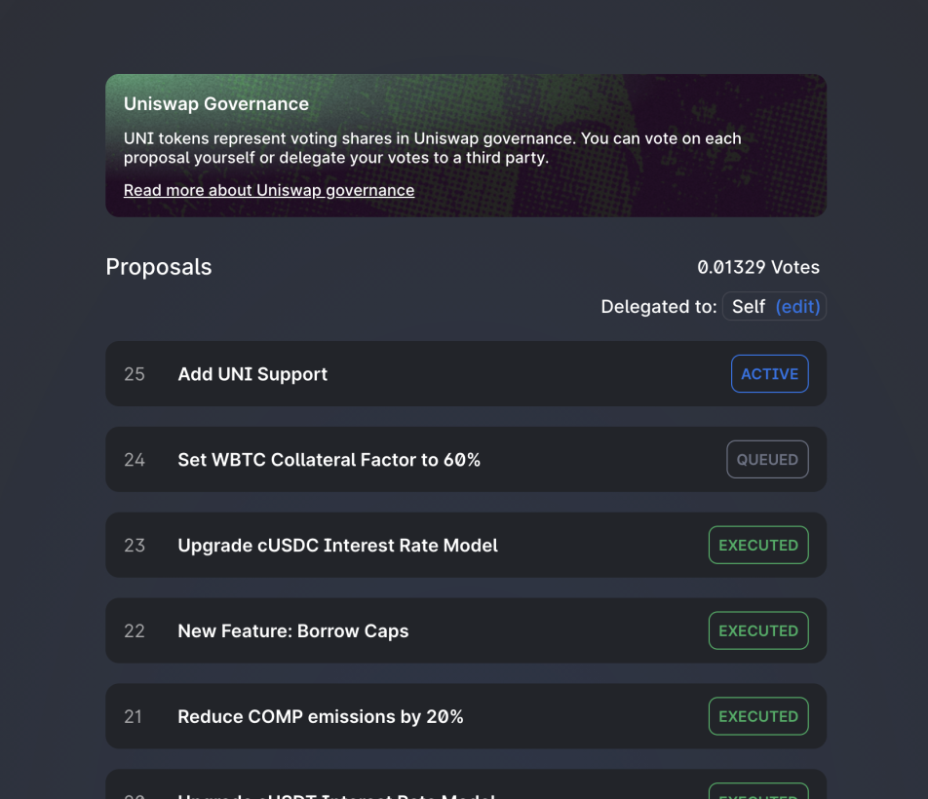

If a proposal is currently live for voting, it will say active next to the title. Clicking the proposal will show all the necessary information, documentation, and discussion needed for a voter to make an informed decision.

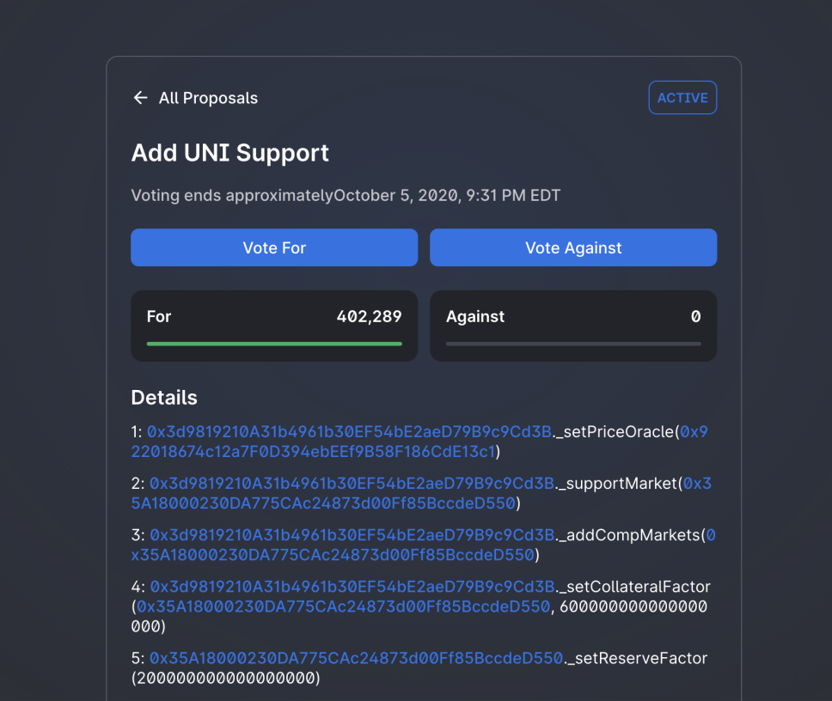

Once a proposal has reached the voting stage it represents real, executable code which will alter the functionality of Uniswap Governance or anything under its jurisdiction - proper care should be taken to ensure that the code represented in the proposal has been audited and is found to be in good faith.

## Delegation[​](https://docs.uniswap.org/concepts/governance/guide-to-voting#delegation)

UNI is a tradable asset and functions like most other standard ERC20 tokens, except it has a deeper power as a voting mechanism. In order for UNI to be used as a vote, the owner must first go through the delegation process. Delegating UNI binds the voting power of your tokens to an address so it may be used to vote. This address could be yourself, or a trusted party who you believe will vote in the best interest of Uniswap Governance.

A democratic consensus, in our process called “quorum”, is determined by the percentage of UNI tokens in favor of, or against, a proposal. 1% of all UNI must be cast in favor to submit a proposal, and 4% in order to pass a vote.

To delegate your UNI tokens and enact their voting power, visit the [Uniswap voting dashboard](https://app.uniswap.org/#/vote) and click the button that says “Unlock Voting”.

Once you click this button, you will see a screen that gives you the option to self delegate, or add a delegate address. If you wish to delegate your UNI voting power to your own address, click “Self Delegate”.

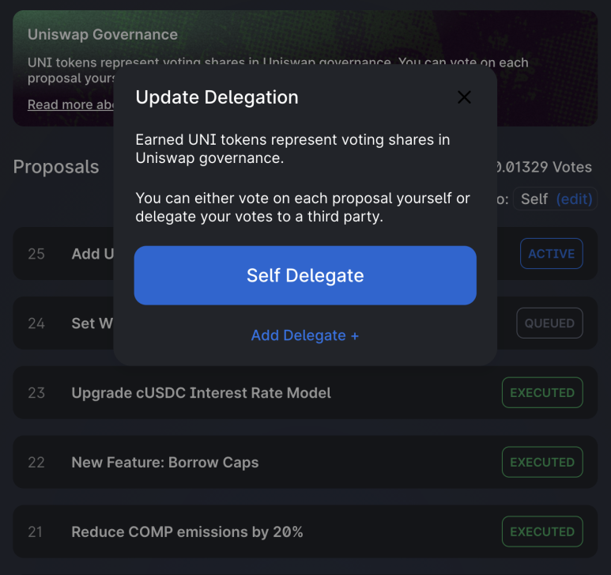

When you click “Self Delegate”, a transaction will pop up in Metamask. If this doesn’t happen, double check that metamask is connected to app.uniswap.org, turn off any popup blockers, and try again. Click confirm, and once the transaction has processed, you will see that the voting dashboard homepage has changed to show the number of votes you have, and “Delegated to: Self”.

If you wish to delegate your voting power to another party, choose “Add Delegate” and enter the ethereum address of your chosen voting party.

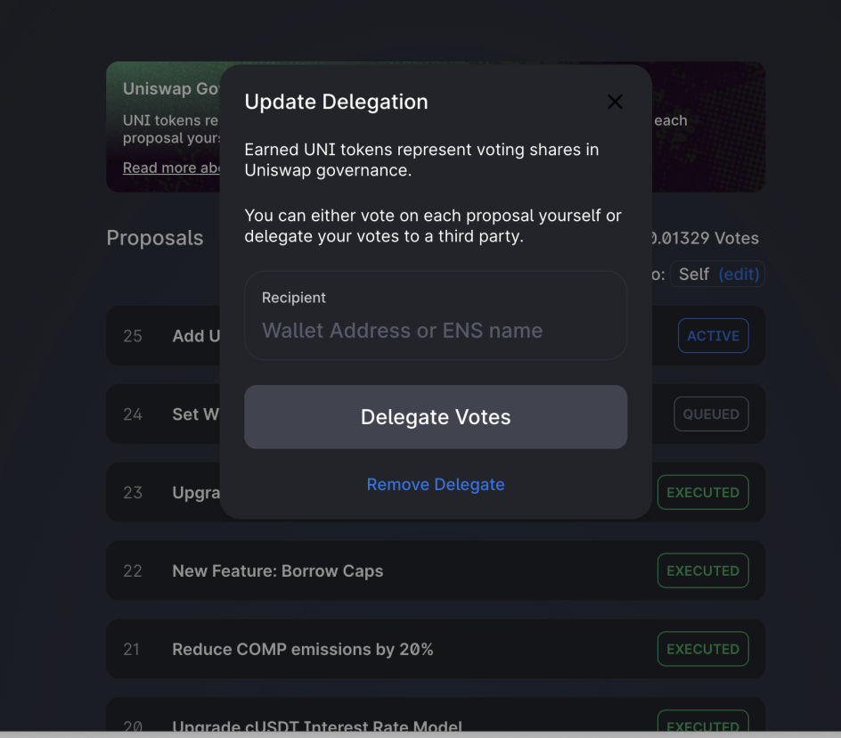

An important note: much like voter registration in a larger democracy, for UNI to be used in a vote it must be delegated before both the voting period and the preceding proposal period. This means if you want your vote to count, you must delegate it in anticipation of any proposal you may be interested in.

If you are unsure of how best to vote and are interested in delegating your UNI voting power to another party, you can visit the [Delegation Pitch](https://gov.uniswap.org/c/delegation-pitch/6) section of the governance forum. Here parties participating in Uniswap Governance pitch their platform and voting agenda for users to read and discuss.

## Voting[​](https://docs.uniswap.org/concepts/governance/guide-to-voting#voting)

If you have successfully self delegated and there is an active proposal, you are ready to vote in Uniswap Governance.

To cast your vote, navigate to the proposals page and click on an active proposal.



After reviewing the attached details and deciding your opinion, choose “Vote For”, or “Vote Against”.



Once you’ve chosen, a window will pop up allowing you to execute the vote.

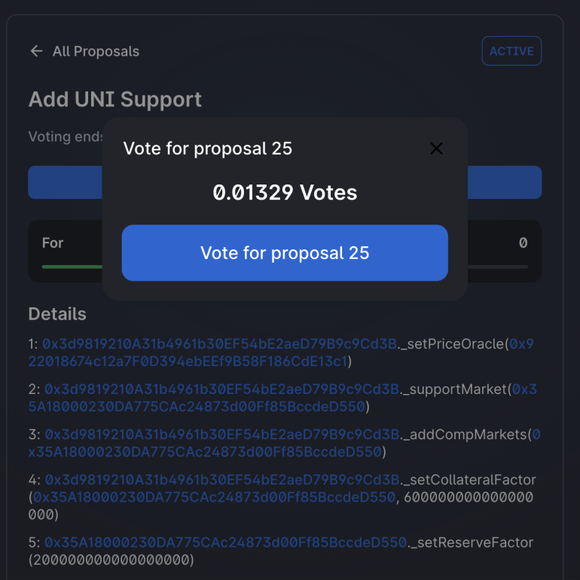

When you click to cast your vote, metamask will pop up asking you to confirm your transaction. Click “submit”, wait a bit, and check that the transaction has been confirmed.

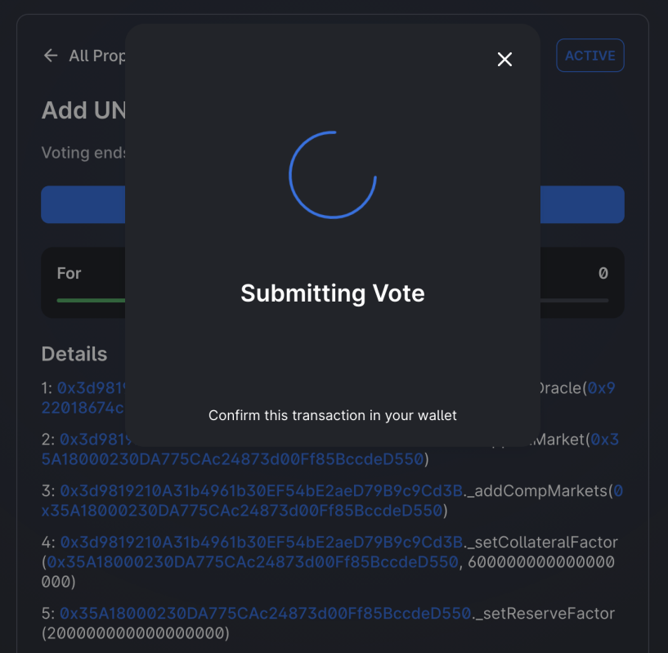

That’s it! Once your transaction has been confirmed, you will have cast your vote and participated in Uniswap Governance.

# Adversarial Circumstances

This document explores some adversarial circumstances which Uniswap Governance may encounter in the future. Its goal is to help those interested in Uniswap Governance understand the reasoning behind some of its design, its limitations, and potential avenues for growth.

## Scenario 1[​](https://docs.uniswap.org/concepts/governance/adversarial-circumstances#scenario-1)

A good faith proposal is brought to vote but is found to have an exploitable edge case. A bad faith actor uses a series of DeFi leveraging strategies to quickly buy enough UNI during the voting period to sway the vote in favor of the proposal, passing it and exploiting the vulnerability.

### Circumvention[​](https://docs.uniswap.org/concepts/governance/adversarial-circumstances#circumvention)

UNI voting power must be delegated to an address either entirely before a proposal has been submitted or during the proposal delay period. For now, the proposal delay is set to one block, which is about 15 seconds. A proposal delay of one block leaves no opportunity for a third party to find an exploitable edge case and opportunistically purchase uni, self delegate and sway the vote.

In the future, Uniswap Governance may vote to increase the proposal delay. While there are obvious benefits to an increased proposal delay, It may introduce some potential adverse outcomes such as opportunistic edge case exploitation.

## Scenario 2[​](https://docs.uniswap.org/concepts/governance/adversarial-circumstances#scenario-2)

A bad faith proposal is crafted and submitted to vote, which is unambiguously not in the best interest of Uniswap Governance. Multiple parties collude ahead of time to corner the UNI market（垄断UNI市场） to force the proposal through, gain access to the UNI reserves, and drain the funds.

### Circumvention[​](https://docs.uniswap.org/concepts/governance/adversarial-circumstances#circumvention-1)

Since UNI is a freely tradable asset, anyone can attempt a governance takeover via market buying. That said, to force-pass a bad faith vote would require a minimum of 40 million UNI. If not outright impossible, this amount would be prohibitively expensive and likely cost more when accounting for price fluctuation than the net gain from the attack.（如果不是完全不可能，这个金额将是非常昂贵的，而且考虑到价格波动，成本可能比攻击的净收益还要高。）

If a group somehow achieved a bad faith takeover, Timelock's delay would give affected agents time to withdraw their assets from the protocol. This would also be an opportunity to fork the protocol, a path that would likely be taken by the remaining good-faith actors.

## Scenario 3[​](https://docs.uniswap.org/concepts/governance/adversarial-circumstances#scenario-3)

A single party uses a flash loan to push through a proposal, potentially creating a pseudo-DDOS attack by spamming governance with proposals and preventing effective use.

### Circumvention[​](https://docs.uniswap.org/concepts/governance/adversarial-circumstances#circumvention-2)

A delegated balance of 2.5 million UNI is required to submit a vote, but the balance check is set exactly one block in the past. This prevents any flash loan proposals from being created, as flash loans cannot execute outside of a single block.

The proposer must also maintain a minimum balance of 2.5 million UNI throughout the voting period, or anyone may cancel the proposal. This balance maintenance check prevents many highly leveraged proposal techniques that may span several blocks.

## Scenario 4[​](https://docs.uniswap.org/concepts/governance/adversarial-circumstances#scenario-4)

A bad faith proposal is created, which will genuinely incentivize bad faith voting.

Example: "The treasury will be drained. Any votes in favor will be sent the balance of the treasury. Any votes opposed will be locked from the funds of the treasury."

### Circumvention[​](https://docs.uniswap.org/concepts/governance/adversarial-circumstances#circumvention-3)

No mechanism explicitly prevents this type of scenario, but market forces disincentivize it.

Because the treasury is comprised of UNI tokens exclusively, the market would react appropriately if a vote were to pass that would jeopardize the economic viability of Uniswap Governance and the UNI token. By the time the vote would pass, UNI's price would have fallen so low as to make the attack fruitless.（由于国库完全由UNI代币组成，如果投票通过，将危及Uniswap治理和UNI代币的经济可行性，市场将做出适当的反应。到投票通过时，UNI的价格已经跌到如此之低，以至于攻击毫无结果。）

UNI acting as the only asset of the governance treasury disincentivizes this form of bad faith voting. Uniswap Governance may choose in the future to diversify governance assets. While there are many benefits to this path, some fringe possibilities such as incentivized bad faith voting may appear.（UNI作为治理国库的唯一资产，抑制了这种形式的恶意投票。Uniswap治理将来可能会选择使治理资产多样化。虽然这条道路有许多好处，但也可能出现一些边缘可能性，如激励恶意投票。）